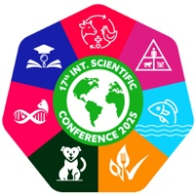
17th International Scientific Conference 2025
Abstract Evaluation Form

Abstract Number: …………………………
Abstract Title: …………………………………………………………………..
Sub-theme: 1/ 2/ 3/ 4/ 5/ 6/ 7
Rubric criteria and point distributions
Points | Rubric criteria
3 | Excellent
2 | Good
1 | Poor

Please provide your evaluation points for each rubric criterion on the following table:

Rubric criteria | Points
Relevance to Conference Sub-theme
Rationale of the study
Clarity and Structure
Scientific Quality (Methods & Results)
Originality / Impact
Language & Style
Total points

Each criterion bears 3 points
- Scoring & Decision
  - 13–18 points → Accept (Oral Presentation)
  - 9–12 points → Accept (Poster Presentation)
  - Less than 9 points → Reject (low quality, unclear, or irrelevant)
Decision: ……………………………………………………………………………..

